Preconstruction Announcement and Schedule
Summary:

Crestview Residents, Board, and Management -
As most of you know, there is a large project in your community that is about to begin. There will be 2 phases of construction, we are about to start phase 1. We have spent countless hours working with your board on finding the correct solutions for buildings within your community.
For this process to work as smoothly as possible, we are going to need the cooperation of all of you. We are now one big team! So, without further ado, we would like to welcome you to the Clearcut Team!
We at Clearcut pride ourselves with providing building systems and products that last and withstand the test of Utah weather and time. We will be submitting a tentative schedule for the project. This schedule will evolve as we progress. Throughout the construction process, schedules will be updated biweekly.
Starting Monday May 8th, we will begin setting up staging areas located by buildings E and D.
May 15th will begin the construction project, we will start to mobilize, set up equipment, scaffold, ladders, planks, and staging areas (see staging map).
On May 15th we will begin the actual demolition (map shown below). Unfortunately, demo and construction can be very noisy and disruptive. We will try our best to minimize this, but during the hours of 7:30am– 5:30pm Monday through Friday, we will be making noise. There will be times when we are working outside of your homes that it may feel like we are going to come right through your walls. We will try our best to limit this, but it will happen more than you probably want.
Please note to be careful driving/walking through the community as equipment and workers will be actively moving throughout the community and parking lots. If you have questions while we are working, please speak with one of our onsite supervisors or superintendents. You can also reach out to us at Info@clearcututah.com or 801-394-3242

Important Information for Homeowners
- Staging will start May 15th.
- We will be starting with Stage 1 construction May15th.
- Please remove/protect any exterior furniture, grills, etc. from your decks (Buildings E & D), as well as any other personal items on or around your unit that you do not want to get potentially damaged or go missing during construction.
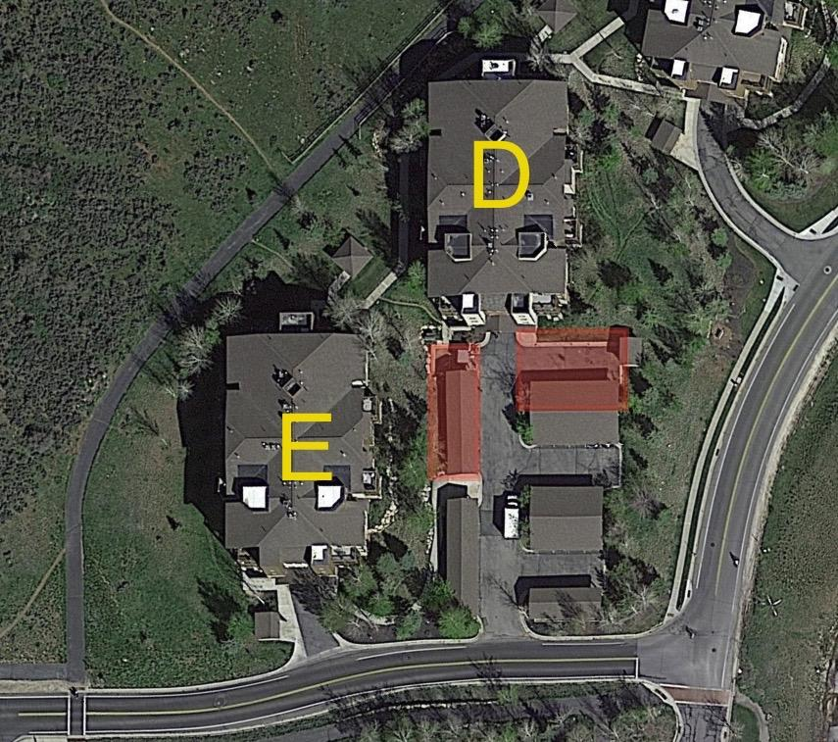
Important Information for Homeowners in buildings E & D
Starting May 8th, 2023, no parking will be allowed in the areas highlighted in red (See map above)

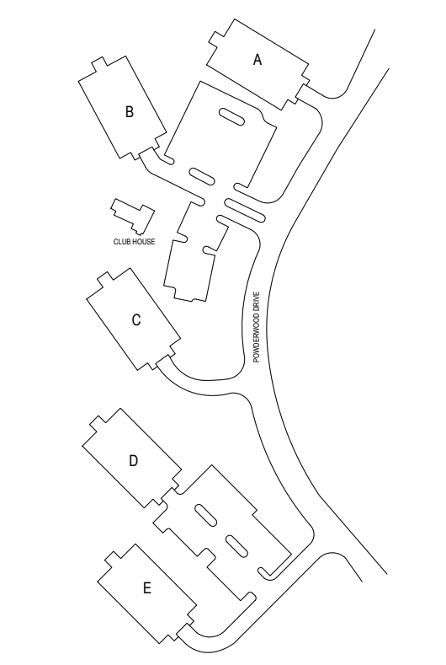
Community Site Map (s)

Phase 1
May 2023- December 2023
Phase 2
May 2024- November 2024

All Roofing to be completed.
Both phases.
June-October 2023

Scheduling: PRELIMINARY SCHEDULE AND IS SUBJECT TO CHANGE

May 15th–June1st: Construction set up. Setup scaffolding, dumpster location(s), material storage, and setup fencing area around storage area.

Tentative Schedule

Phase 1
Building E
May 1, 2023-October 13, 2023
Building D
June 12, 2023-December 10, 2023
Building B
July 10, 2023-December 3, 2023
Phase 2
Building C
May 13, 2024-August 19, 2024
Building A
June 10, 2024-November 8, 2024

This project is going to drastically improve your buildings. Our main goal is to ensure the building envelope is watertight. We look forward to working with you throughout this summer and fall. We will do our best to communicate every step of the way. If you have additional questions or concerns, you can reach out to us at - info@clearcututah.com

**For after hour issues or work-related emergencies please call our 24/7 Phone Line (801) 394-3242 and someone from Clearcut will be informed.

Thank you,
Your Clearcut Management Team

